CMP9767M - Robot Programming - Localisation

Dr Grzegorz Cielniak

Overview
Part I Odometry, Part II Map-based, Part III GNSS-based
ROS concepts:nav_msgs/Odometry, robot_localisation,amcl.

Base material:
Moore, 2015 ROSCON presentation https://vimeo.com/142624091

robot_localisation wiki, http://docs.ros.org/melodic/api/robot_localization/html/index.html

Robot Localisation
Answers the question “Where am I?”
Estimates the robot’s state (??)
With the use of sensors (wheel encoders, IMU, laser, cameras, GNSS)
With respect to: the robot’s starting position (odometry) or global (map,
GNSS) coordinates
Essential capability for robot navigation

Part I – Odometry reckoning
Localisation based on the previously calculated pose and velocity estimation – starting from 0, robot’s initial pose.
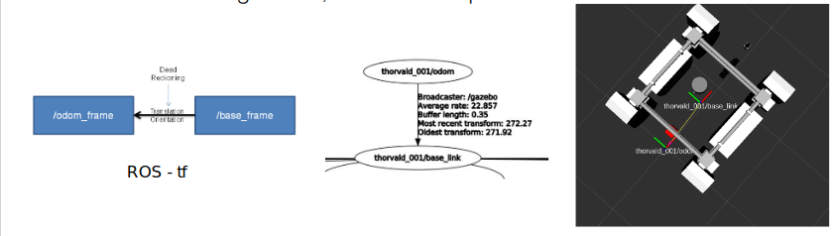
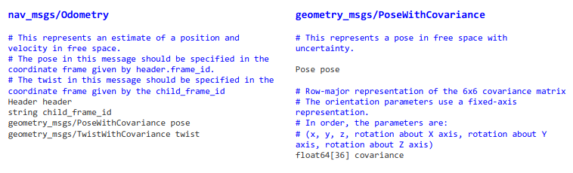
Odometry Variants
Odometry is not only limited to wheel encoders, can be visual- or laser-based. E.G. in visual odometry the velocity is estimated from matching consecutive camera images.

Library for Visual Odometry,
http://www.cvlibs.net/software/libviso/
https://www.youtube.com/watch?v=0sq1O8U2TWk

Odometry Drift
All odometry solutions suffer from the inherent drift problem.
Statistical estimators such as the Kalman filter can reduce the drift but cannot completely eliminate it.
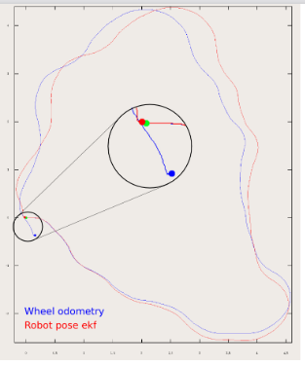
Fusing information from multiple odometric sensors has similar effect.

Kalman Filter
A statistical estimator which filters the noisy measurement data Models measurement uncertainty and propagates that over time Exploits the knowledge about typical state changes (i.e. motion models)
Can fuse observations from multiple sources
Two step iterative procedure:

Occupancy Map

Next Week
Navigation
Prep material:
• navigation wiki, http://wiki.ros.org/navigation
• Yehoshua, 2016 https://u.cs.biu.ac.il/~yehoshr1/89-685/

